

MDCare Group Ltd

Carbon Reporting and Reduction Plan

Baseline year June 21 to May 22.

Previous Year Reporting June 23 to May 24.

Current reporting year June 24 to May 25.

Contents

1. Introduction 2
2. Scope 1, 2 and 3 Emissions Definitions 2
3. Carbon impact for the baseline year June 2021 to May 2022 3
3.1 Carbon emissions by source. 4
4. Carbon impact for the current reporting year June 2024– May 2025 5
4.1 Carbon emissions by source. 5
5. Comparison of reporting years 7
6. Carbon Assessment Observations 8
7. Carbon Reduction Commitments /Actions 8
8. Measurement 9
9. Prioritise 10
10. Action Plan 11
11. Carbon Reduction Trajectory 11
12. Audit 14
13. Offsetting 14
14. Declaration 15

Introduction

MDCare Group Ltd has committed to reducing its carbon emission to Net Zero by 2035, using as far as possible direct reduction, and offsetting the remainder.
We do this because we are conscious of the environmental, social and economic imperative to act on climate change.

The UK Government amended the Climate Change Act 2008 in 2019 by introducing a target of at least 100% reduction in the net UK carbon account (i.e. a reduction of greenhouse gas emissions when compared to 1990 levels) by 2050. As a result, Central Government Departments, their Executive Agencies and Non-Departmental Public Bodies are required to ensure that suppliers to contracts with an annual value of in excess of £5 million (excluding VAT) per year are committed to achieving "Net Zero by 2050" for all procurements after 30th September 2021.

This has led to PPN 06/21 which applies to all new procurements from this date and this includes framework call-offs and Dynamic Purchasing Systems where the anticipated individual value of the call-off or DPS is £5 million (excluding VAT) per annum or more. To demonstrate compliance, we have set out our environmental management measures in our Carbon Reduction Plan which includes:

- Confirming our commitment to achieving Net Zero by 2050 for our UK operations.
- Details of our carbon footprint/current emissions for the sources included in Scope 1 and 2 of the GHG Protocol and a defined subset of Scope 3 emissions.
- Providing emissions reporting of the CO2e (Carbon Dioxide Equivalent) for the greenhouse gases covered by the Kyoto Protocol (predominantly carbon dioxide, methane and nitrous oxide).
- Setting out the environmental management measures we have adopted including specific carbon reduction measures.
- Publication of our Carbon Reduction Plan on our website.

Scope 1, 2 and 3 Emissions Definitions

Scope 1 Direct Emissions - these are direct greenhouse gas emissions that occur from sources that are controlled or owned by us (e.g. emissions from boilers, vehicles etc).

Scope 2 Energy Indirect Emissions - these are indirect greenhouse gas emissions associated from the purchase of electricity, heating or cooling and are measured and reported in alignment with our energy use.

Scope 3 Other Indirect Emissions - these fall into 15 categories and include all sources not specified within Scopes 1 and 2 above. The Scope 3 emissions that we are required to report on are:

- “Upstream” transportation and distribution of products purchased by us from Tier 1 suppliers (e.g. paper, computers, office consumables).
- Disposal and treatment of waste generated in facilities not owned or controlled by us.
- Transportation of employees for business related activities in vehicles not owned or operated by us.
- Transportation of employees between home and work in vehicles not owned or operated by us including in their own vehicles.
- “Downstream” transportation and distribution of products sold by us including retail and storage. This category is not applicable as MDCare Group is a service business and does not produce, transport or distribute products.

Carbon impact for the baseline year June 2021 to May 2022

The tables below show our carbon footprint in our baseline year June 21 to May 22 when we first started measuring our emissions.

Baseline Year: | June 21 – May 22
Baseline Emissions Calculations: | All Scopes – tonnes CO2e/ year
Scope 1 CO2e:
  0.000
Scope 2 CO2e:
  0.943
Scope 3 CO2e (included sources):
  8.745
Total Emissions:
  9.688

3.1 Carbon emissions by source.

 | Tonnes CO2e
Electricity | 0.943
Heating fuel | n/a
Water | 0.000
Consumables | 0.007
Waste | 0.115
Business Travel | 0.000
Commuting | 8.622
Total | 9.688

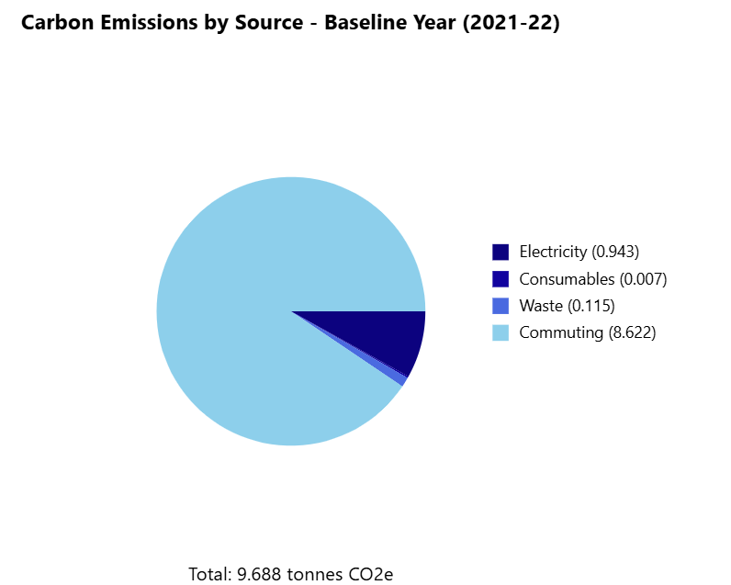

  - Carbon Emissions by Scope

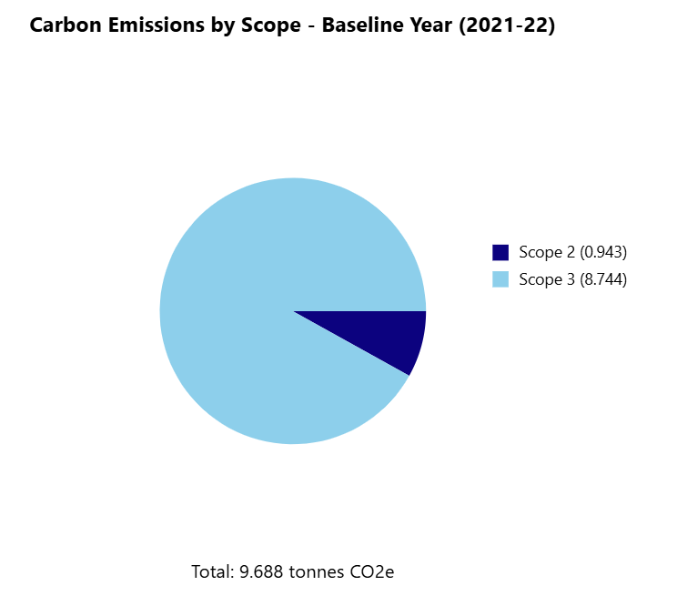

Carbon impact for the current reporting year June 2024– May 2025

The tables below show our carbon footprint in our current reporting year June 2023 to May 2024.

Current Year: | June 24 – May 25
Baseline Emissions Calculations: | All Scopes – tonnes CO2e/ year
Scope 1 CO2e: | 0.000
Scope 2 CO2e: | 3.350
Scope 3 CO2e (included sources): | 29.850
Total Emissions: | 33.20

4.1 Carbon emissions by source.

 | Tonnes CO2e
Electricity | 3.350
Heating fuel | n/a
Water | 0.620
Consumables | 0.025
Waste | 0.230
Business Travel | 2.450
Commuting | 26.525
Total | 33.200

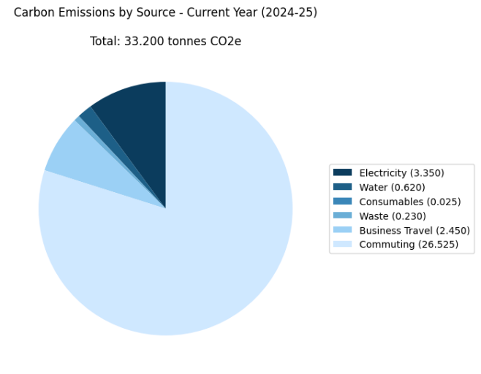

  - Carbon Emissions by Scope
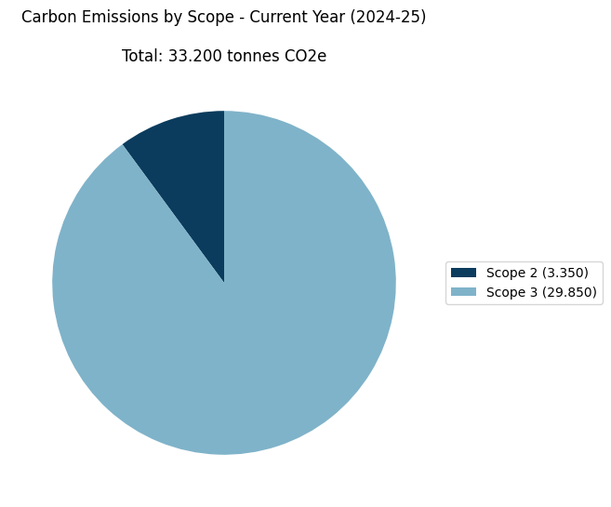

Comparison of reporting years

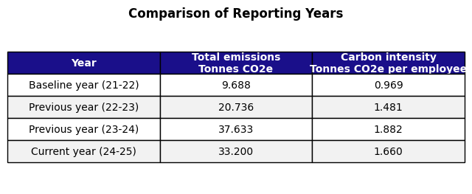

5.1 Analysis

There has been a significant increase in overall emissions between the baseline year and the most recent reporting period, followed by a reduction in the current year (2024–25), demonstrating the early impact of targeted carbon reduction measures.
The most notable changes include:
- Overall emissions trend
  - Total emissions increased from 9.688 tonnes CO2e (baseline) to 37.633 tonnes CO2e (2023–24), primarily due to:
    - Growth in workforce and operational scale
    - Introduction of additional emission sources (water usage and business travel)
    - Increased electricity consumption
    - Higher commuting emissions
  - In the current reporting year (2024–25), emissions have reduced to 33.200 tonnes CO2e, reflecting initial improvements in operational efficiency and behavioural changes.
- Carbon intensity per employee
  - Carbon intensity increased from 0.969 to 1.882 tonnes CO2e per employee between the baseline and 2023–24, indicating:
    - Increased per-person environmental impact
    - Evolving commuting patterns
    - Expanded business activity
  - In 2024–25, carbon intensity has reduced to 1.660 tonnes CO2e per employee, demonstrating improved efficiency relative to workforce size.
- Key emission drivers
  - The largest contributors to emissions remain:
    - Commuting (reduced from 30.614 to 26.525 tonnes CO2e), reflecting early impact of hybrid working and reduced travel frequency
    - Electricity usage (reduced from 3.912 to 3.350 tonnes CO2e), indicating improved energy management
    - Business travel (increased slightly to 2.450 tonnes CO2e), reflecting continued growth and client engagement activity
- Operational context
  - The increase in emissions between baseline and 2023–24 is directly linked to organisational growth and expanded UK service delivery.
  - The subsequent reduction in 2024–25 demonstrates the organisation’s ability to stabilise emissions while maintaining operational delivery, supported by:
    - Increased hybrid and flexible working
    - Improved travel planning and prioritisation
    - Greater awareness of energy and resource consumption

Carbon Assessment Observations

MDCare Group operates from one office in Chelmsford Essex. The following observations were made for the current reporting period:
- Transport Patterns:
  - High car dependency (60% of workforce)
  - Good public transport utilization (35% combined bus and train)
  - Active travel currently limited to 5% of workforce
  - Average commuting distance: 146 miles per week per employee
  - Significant variation in individual commuting distances (7-480 miles per week)
- Resource Usage:
  - Substantial increase in electricity consumption
  - Water usage now being actively monitored
  - Increased waste generation tracking with workforce growth
  - Modern, B-rated EPC building provides good efficiency baseline
- Business Operations:
  - Significant business travel (7,640 miles annually)
  - Growing workforce with 43% increase in headcount
  - Carbon intensity at 1.882 tonnes CO2e per employee

Carbon Reduction Commitments /Actions

Based on the current reporting period, we propose the following priority actions:
- Sustainable Transport Program:
  - Launch car-sharing scheme targeting employees with similar commute routes
  - Expand cycle-to-work scheme with enhanced facilities
  - Investigate electric vehicle charging infrastructure
  - Implement hybrid working policy where possible
  - Target 25% reduction in car commuting by 2025
- Business Travel Optimization:
  - Implement virtual-first meeting policy
  - Establish clear criteria for essential travel
  - Develop travel hierarchy prioritizing low-carbon options
  - Set up tracking system for travel emissions
- Resource Efficiency:
  - Conduct energy audit to identify high consumption areas
  - Install smart meters and monitoring systems
  - Review building management system settings
  - Implement power management policies for IT equipment
- Employee Engagement:
  - Create green transport champions
  - Monthly sustainability newsletters
  - Recognition program for sustainable commuting
  - Regular carbon reduction workshops

Measurement
We report on the sources of environmental impact over which we have operational control and calculate our carbon footprint monthly, in accordance with the Greenhouse Gas (GHG) Protocols Corporate Standard and report against the Kyoto Protocol greenhouse gasses in terms of:
- Actual targets -- absolute reduction targets which compare actual figures in the target year to those in the base year.
- Intensity targets -- based on a normalising factor.

We subscribe to a third party service to manage our data inputs, conduct the required calculations, set and record our intensity metrics, and provide monthly carbon reporting. The data that sits behind this is the UK Government Greenhouse Gas reporting database, updated when appropriate.

This provides us with our emissions by source, and total emissions by month, sets our intensity metrics and shows how we are tracking month-on-month.
Our chosen intensity metrics are kg/CO₂ per employee.

For the current year therefore, our Carbon Intensity is:

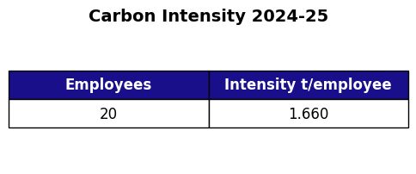
Our base year for all measurements is June 21 to May 22. This will not change unless there is a significant change to our company structure (e.g. a merger or acquisition) or a change in the company's ownership, in which case the base year may move to the reporting year following the structural change.
Specific inputs and output used to calculate figures quoted in our Carbon Reduction Plan include:
- Electricity
- Water
- Solid waste
- Employee commuter mileage by type -- walk / cycle / motorcycle / car / bus / train
- Business travel by private car / bus / rail
- Office consumables
Conversion Factors The conversion factors used throughout are the '2023 UK Government Greenhouse Gas Conversion Factors for Company Reporting.

Prioritise
Our monthly carbon calculation has enabled us to identify the largest sources of GHG emissions, and to focus our areas of impact. That does not imply however that we are not implementing actions across the board. We have been able to identify quick and easy wins which relate to relatively low impact areas whilst also implementing longer term multi-facet strategies for the larger emission areas.
Based on our current year's data (2023-24), our priorities are determined by the following emission sources:

- Commuting (30.614 tonnes CO2e, 81.3% of total emissions)
  - Focus on reducing single-occupancy car journeys
  - Target car users within cycling distance
  - Promote existing public transport connections
  - Investigate car-sharing potential for employees with similar routes
  - Consider flexible working arrangements to reduce commuting frequency

- Business Travel (2.139 tonnes CO2e, 5.7% of emissions)
  - While business travel reflects our successful UK market expansion, we can:
  - Optimize journey planning to reduce mileage
  - Prioritize rail over car for longer distances
  - Combine multiple client visits in single trips
  - Use virtual meetings where appropriate

- Electricity (3.912 tonnes CO2e, 10.4% of emissions)
  - Investigate energy efficiency measures
  - Review IT equipment power management
  - Consider renewable energy options with landlord
  - Monitor usage patterns in relation to occupancy

- Water, Waste and Consumables (Combined 0.968 tonnes CO2e, 2.6% of total)
  - Maintain current reduction initiatives
  - Improve recycling rates
  - Monitor water consumption
  - Minimize paper usage

Action Plan

Our action plan focuses on the following key areas:
- Sustainable Transport
  - Expand cycle-to-work scheme
  - Provide additional facilities for cyclists
  - Promote car sharing initiatives
  - Support transition to electric vehicles
- Business Travel
  - Implement virtual-first meeting policy
  - Optimize trip planning and combining purposes
  - Prioritize rail travel over car where possible
  - Track and report travel emissions monthly
- Energy Efficiency
  - Regular energy audits
  - LED lighting upgrades
  - IT equipment power management
  - Building management system optimization
- Resource Management
  - Enhance recycling programs
  - Reduce paper consumption
  - Water conservation measures
  - Sustainable procurement policies

Carbon Reduction Trajectory

We have set emissions reduction targets by source as percentage reductions against our baseline year (June 2021 – May 2022), with interim targets for 2025 and 2030, and a longer-term ambition of achieving Net Zero by 2035 (with offsetting applied to residual emissions).

Source | Baseline 21–22 | 2025 | 2030 Target | 2035 Target
Electricity | 0.943 | 3.350 | 2.000 | 0.500
Heating fuel | n/a | n/a | n/a | n/a
Water | 0.000 | 0.620 | 0.500 | 0.300
Consumables | 0.007 | 0.025 | 0.020 | 0.015
Waste | 0.115 | 0.230 | 0.180 | 0.150
Business Travel | 0.000 | 2.450 | 1.800 | 1.000
Commuting | 8.622 | 26.525 | 20.000 | 15.000
Total | 9.688 | 33.200 | 24.500 | 16.965

Trajectory Overview
The increase in emissions between the baseline year and 2023–24 reflects organisational growth, expanded workforce, and increased operational activity. The current reporting year (2024–25) demonstrates the beginning of emissions stabilisation and reduction, forming the basis for future targets.
Our trajectory therefore reflects:
- Short-term stabilisation (2024–2025) following a period of growth
- Medium-term reduction (to 2030) driven by behavioural and operational changes
- Long-term reduction (to 2035) supported by structural and technological improvements, with residual emissions offset

By 2025, we have:
- Begun reducing emissions from staff commuting through hybrid working and travel optimisation
- Stabilised overall emissions following a period of rapid growth
- Improved monitoring and control across key emission sources

By 2030, we will:
- Work with our landlord to transition towards a renewable electricity tariff where feasible
- Achieve sustained reductions in commuting emissions through behavioural change and policy
- Reduce business travel emissions through a virtual-first approach and improved journey planning
- Continue incremental reductions in waste and resource consumption

By 2035, we will:
- Deliver significant reductions in commuting emissions through long-term workforce and travel strategies
- Minimise electricity-related emissions through energy sourcing and efficiency improvements
- Reduce business travel emissions to essential activity only
- Achieve further reductions across all remaining emission sources

Net Zero Position
By 2035, this trajectory represents an approximate 49% reduction from the current reporting position (2024–25). The remaining emissions (~16.965 tonnes CO2e per year) will be addressed through a combination of further reduction initiatives and verified carbon offsetting, enabling the organisation to achieve Net Zero.

Audit
Whilst not compulsory, we have committed to an annual audit of our carbon data reporting, by an independent third party.

Offsetting
Offsetting the emissions that we can’t mitigate will become part of our strategy, but only at the point that we’ve implemented all of the possible behavioural, process and technology changes.

Carbon offsetting is an unregulated market, and has suffered some negative publicity due to exaggerated claims on carbon savings. We also note that the UK market has little capacity at present.

We will take expert guidance to identify a credible and verifiable carbon offsetting scheme, that nay be UK or Overseas based.

Declaration and Sign Off
This Carbon Reduction Plan has been completed in accordance with PPN 006 and associated guidance and reporting standard for Carbon Reduction Plans.

Emissions have been reported and recorded in accordance with the published reporting standard for Carbon Reduction Plans and the GHG Reporting Protocol corporate standard13 and uses the appropriate government emission conversion factors for greenhouse gas company reporting.

Scope 1 and Scope 2 emissions have been reported in accordance with SECR requirements (where required), and the required subset of Scope 3 emissions have been reported in accordance with the published reporting standard for Carbon Reduction Plans and the Corporate Value Chain (Scope 3) Standard.

This Carbon Reduction Plan has been reviewed and signed off by the board of directors (or equivalent management body).


sup
Signature:

Name: Darren Simpkin

Job Title/Designation (must be a director or equivalent): Sales Director

Date: 10th August 2024

